**TASK 01. Comparing 2 AI Image generators by using different AI Image tools i.e., (Midjourney v/s Leonardo AI)**

**IMAGE 1**

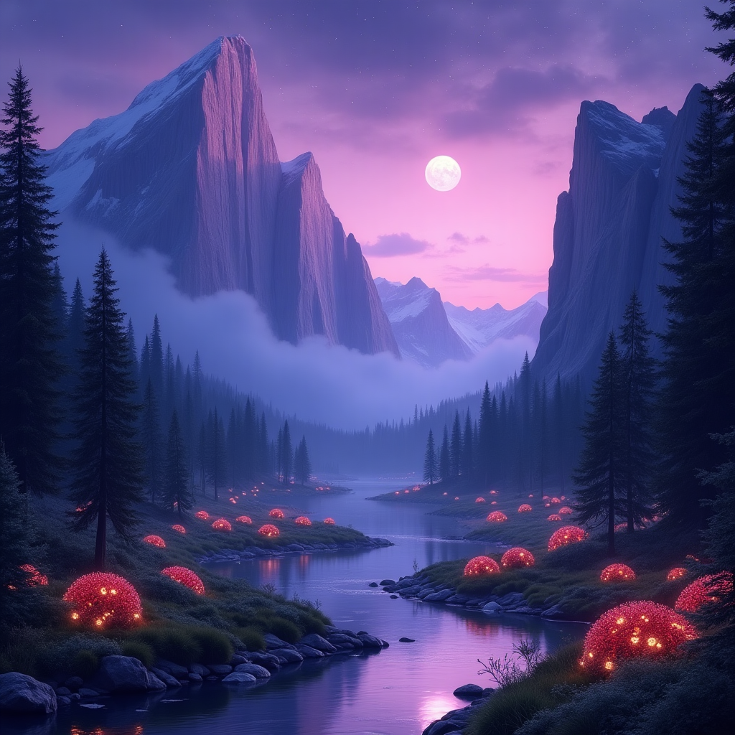

**IMAGE 2**

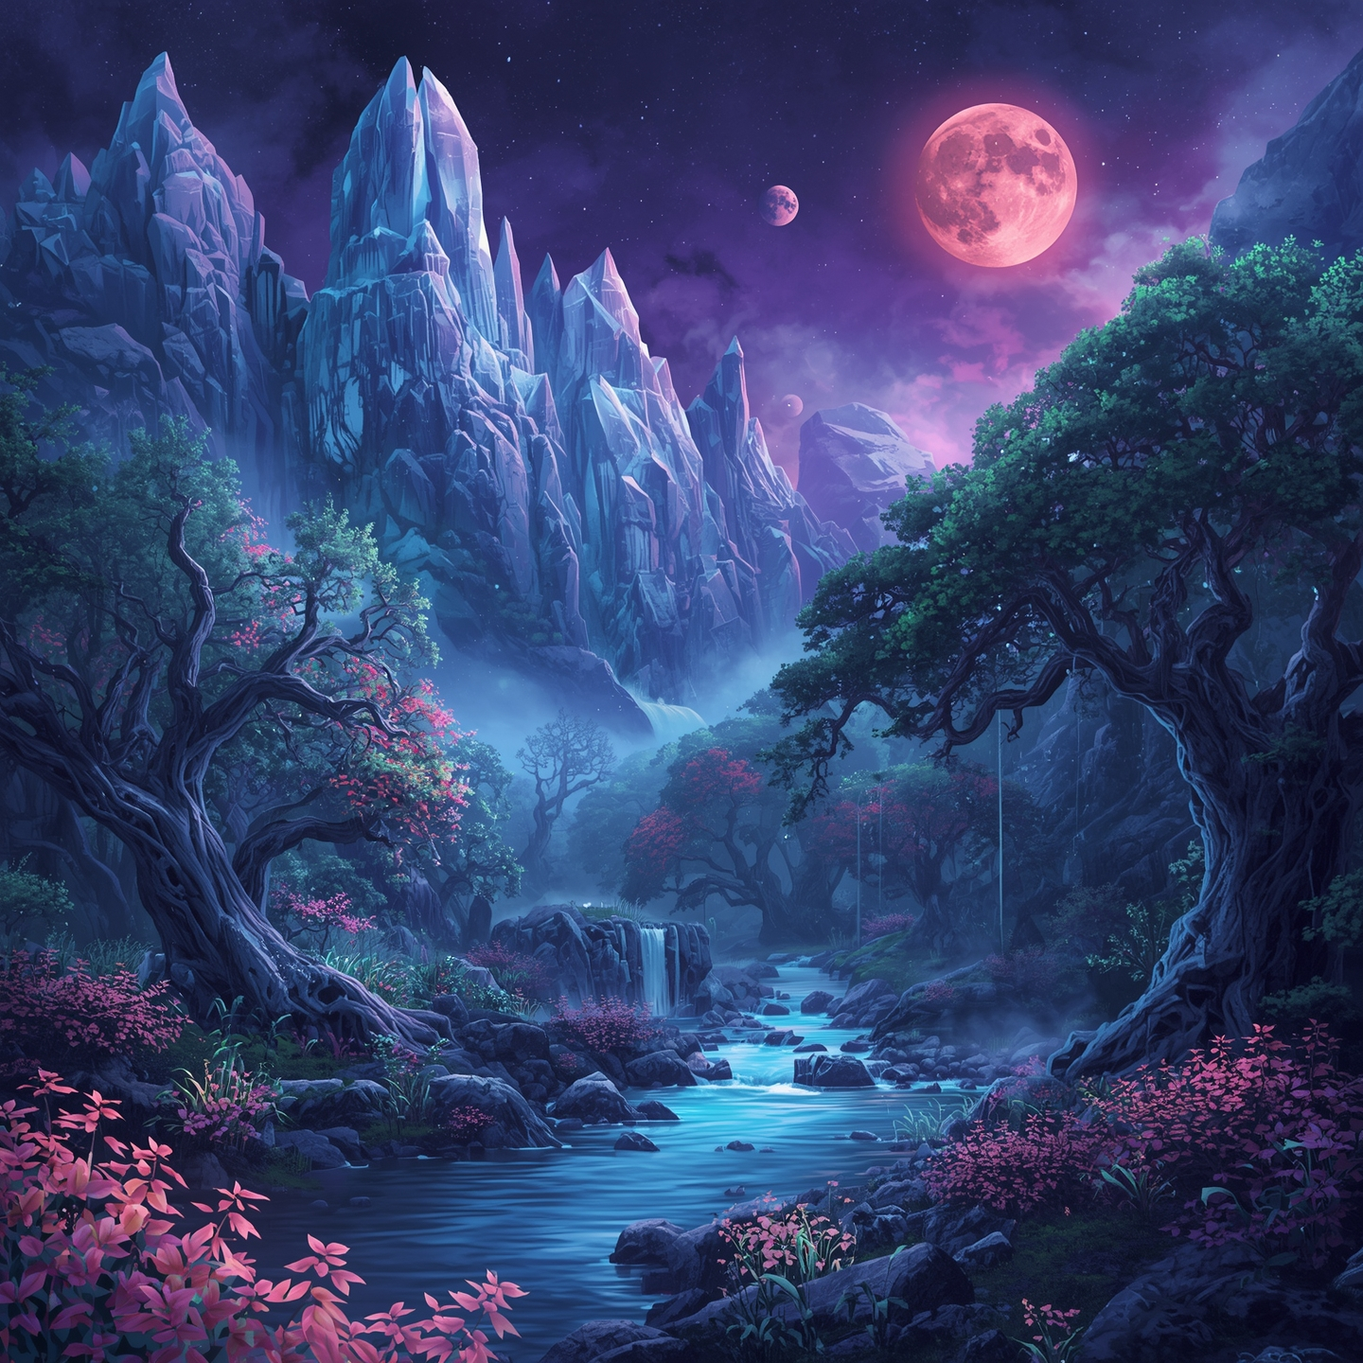

### **1. Image Quality**

* **Image 1**: Very sharp, high-resolution, with smooth gradients and strong lighting effects. The glowing red orbs and mist give it a polished, cinematic feel.
* **Image 2**: Equally detailed, but with more vibrant colors (blues, purples, reds). It leans towards a more painterly, magical realism style, with crisp details in foliage and mountains.

➡️ **Verdict**: Both are high quality, but **Image 1 feels more photorealistic**, while **Image 2 feels more painterly and vibrant**.

### **2. Prompt Accuracy**

(Based on “breathtaking fantasy landscape with towering crystal mountains”)

* **Image 1**: Has towering mountains, but they look more natural rock-like than crystal. Fantasy glowing elements are present, though.
* **Image 2**: Perfectly fits the “crystal mountains” idea—the peaks look crystalline, plus the vibrant sky and double moons boost the fantasy theme.

➡️ **Verdict**: **Image 2 aligns better with the “crystal mountains” fantasy prompt**.

### **3. Style Flexibility**

* **Image 1**: Strong cinematic, moody, and atmospheric style. Works well for dramatic or mysterious fantasy settings.
* **Image 2**: More versatile—could fit high fantasy, game concept art, or even storybook illustrations. It blends realism with surreal fantasy more openly.

➡️ **Verdict**: **Image 2 shows broader style flexibility**.

### **4. Usability**

* **Image 1**: Excellent for backgrounds in film/game cutscenes, posters, or immersive landscapes where subtle magic is needed.
* **Image 2**: Great for book covers, fantasy world-building, concept art, or media where high fantasy vibes are required.

➡️ **Verdict**: **Both are usable, but Image 2 is more adaptable for creative industries**, while Image 1 suits cinematic presentation.

### **5. Licensing & Terms**

* Since these look like **AI-generated artworks**, licensing depends on the platform used to generate them:  
  + **If created via open-source/local models** → usually no commercial restrictions.
  + **If created via platforms like MidJourney, DALL·E, or Stable Diffusion services** → licensing varies (e.g., MidJourney requires paid plans for commercial use, OpenAI’s DALL·E allows broad use but prohibits certain contexts).

➡️ **Verdict**: **Check the generator’s terms**—if both are from the same platform, their licensing is identical. If different, **Image 1 vs Image 2 licensing depends on the tool used**.

**Task 02. Visual Design Project**

- Create a poster for a fictional event or product.

**Promt**: Poster for a steampunk fair called ‘Gears & Dreams Expo’, with brass gears, steam clouds, flying airships, and vintage-style lettering.”

**Poster:**

